**MAHATMA GANDHI KASHI VIDYAPITH, VARANASI**

**महात्मा गांधी काशी विद्यापीठ, वाराणसी**

**(An Uttar Pradesh State University)**

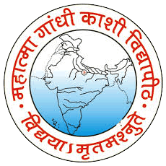

**FACULTY OF SCIENCE & TECHNOLOGY**

**Department of Computer Science & Application**

**MGKVP UNIVERSITY, VARANASI**

**(2019-2022)**

**ONLINE LEARNING**

**A**

**MAJOR PROJECT WORK**

Submitted in partial fulfillment of the Requirements for the Degree of

MASTER OF COMPUTER APPLICATIONS (M.C.A)

**Submitted By: -**

SHASHANK KUMAR SHARMA

Roll No.: - 10020517064

Enroll No.: - KA2K20/100517064

**Submitted To: -**

Dr. Satya Singh (Professor)

Dean: - Faculty of Science & Technology

H.O.D.: - Department of Computer Science & Technology

MAHATMA GANDHI KASHI VIDYAPITH UNIVERSITY VARANASI (U.P)